Week 5
Problem 1
The first code is a GUI to calculate the average student test scores. It uses tkinter to create a GUI and loops through the student to student and score to score to determine each result.
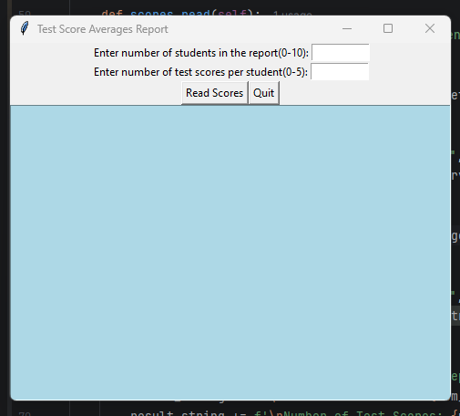
Problem 2
This program is similar to the first one using the number of years to determine when to stop the loop. Using the same tkinter logic as we have done previously this is quite simple to the previous task although the purpose is different.
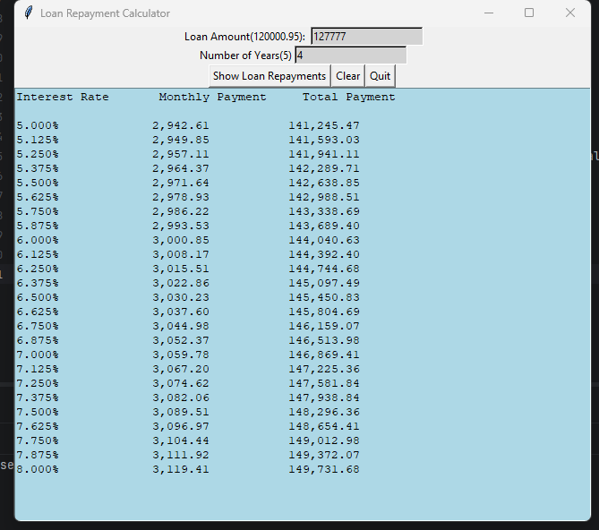

Test Plan
Test ID | Loan Amount | Number of Years | Expected Output Total Payment | Actual Output Total Payment | TEST OK ?
1. | 500,000 | 5 | 566,137.01 | 566,137.01 | YES
2. | 700,000 | 10 | 890,950.33 | 890,950.33 | YES
3. | 250,000 | 3 | 269,738.07 | 269,738.07 | YES
4. | 120,000.95 | 5 | 135,873.96 | 135,873.96 | YES
5. | INVALID INPUT | INVALID INPUT | Error | Error | NO

